# Topological Sort:

Sorts given actions in such a way that if there is a dependency of one action on another, then the dependent action always comes later than its parent action.

Let’s demonstrate this topic by an example:

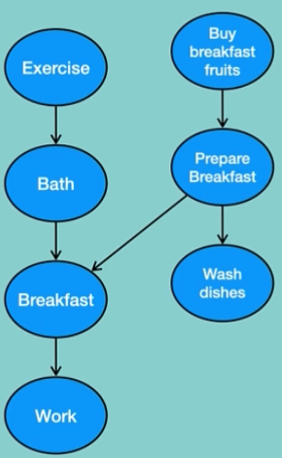

This is how a person does his/her morning routine. We can not have break fast before having done these tree steps (Buy breakfast fruits, prepare Breakfast and wash dishes), so basically it means the action of having breakfast is dependent to do those tree steps. Same in the right side of the Graph (those tree steps) if we haven’t bought breakfast fruits, we cannot prepare one.

Having the breakfast depends on taking bath and prepare Breakfast.

To solve this problem we can implement topological sorting